**A picture containing clipart

Description generated with very high confidence**

Using Loops in Manifest

DevOps Certification Training

[**support@intellipaat.com**](mailto:support@intellipaat.com)

**+91-7022374614**

**US: 1-800-216-8930(Toll Free)**

**USING LOOPS IN MANIFESTS**

**ONLYIF**

**Steps for Puppet Master**

**Step 1:** Change the directory to **/etc/puppet/code/environments/production/manifests**

$ cd /etc/puppet/code/environments/production/manifests

$ sudo nano site.pp

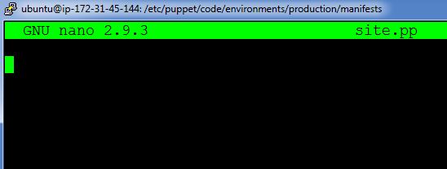

**Step 2:** Enter the following text:

node default{

$packages=> [‘apache2’,’mysql-server’]

package{$packages:

ensure=> installed,

}

}

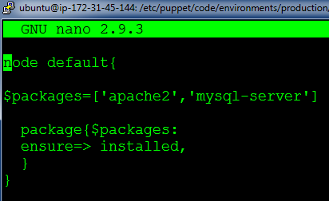

**On Puppet Agent**

**Step 1:** Execute the following command:

$ sudo puppet agent --test

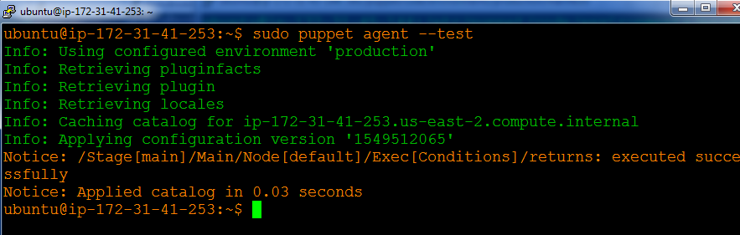

**Step 2:** Verify the installation by going to the browser with Agent’s IP address and mysql service status

